Assignment-19.1
B.Vaishnavi
2303A51657

Batch-28
Task 1 – Python to Java Conversion PROMPT: Create a simple Python class with attributes and methods, then convert it into an equivalent
Java class. Include constructor, proper data types, and method signatures for each and
compare the results of both versions
CODE:

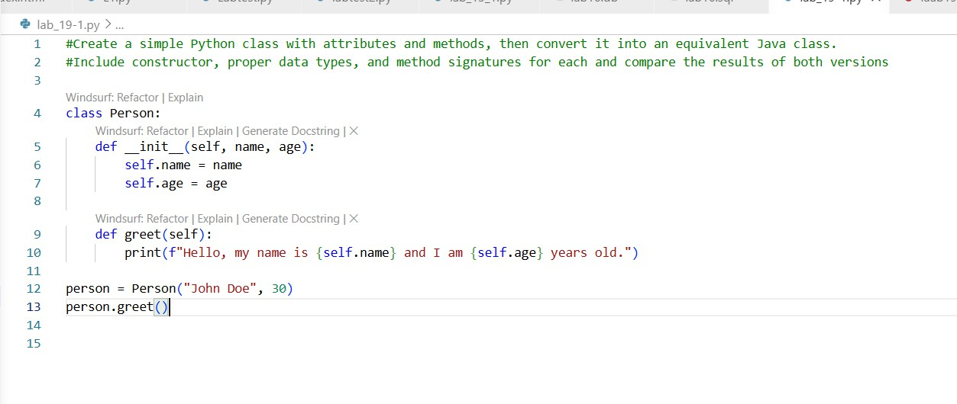
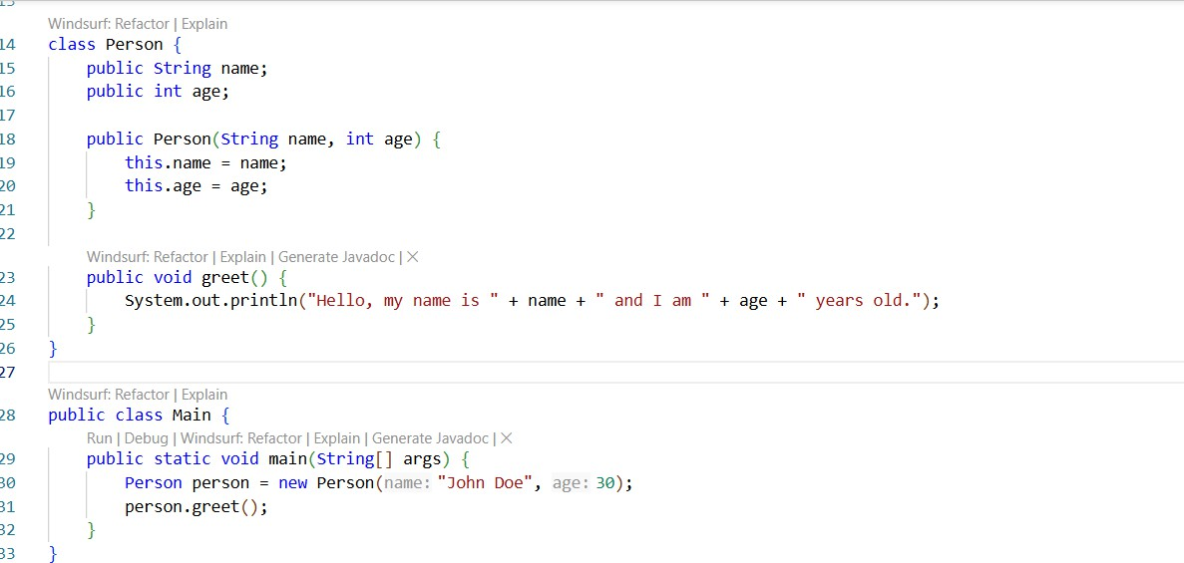

OUTPUT:
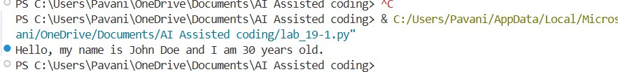

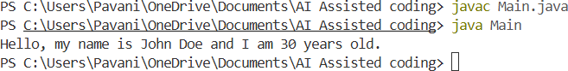

EXPLANATION:
- Python is dynamically typed (no need to declare types), while Java is statically typed (String, int, etc. required).
- Python uses init , whereas Java uses a constructor with the class name.
- Python is indentation-based and simpler; Java uses {} and ; with stricter structure.
- Python runs directly, while Java needs compilation (javac) before running (java).

Task 2 – C++ to Python Function Conversion PROMPT:
Convert a recursive C++ function for calculating factorial into Python. Make sure the Python code is correct, follows Python conventions, and include a few test cases to verify the output
CODE:

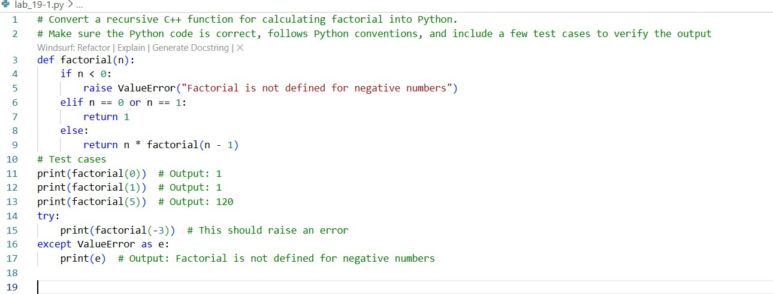
OUTPUT:
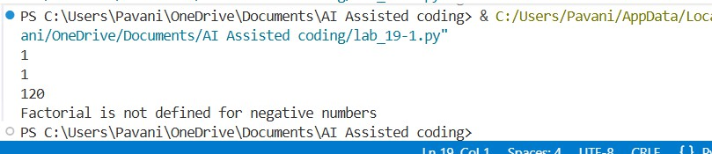
EXPLANATION:
- Convert the recursive C++ factorial function into Python while preserving the same logic and recursion flow
- Replace C++-specific elements (data types, braces, semicolons) with Python’s simpler, indentation-based syntax.
- Test the Python function with sample inputs to ensure correctness and consistency with expected outputs.

Task 3 – SQL to Pandas Query PROMPT:
SELECT name, salary FROM employees WHERE salary > 50000 convert the above sql query into an equivalent pandas code and test the code on sample dataFrame
CODE:

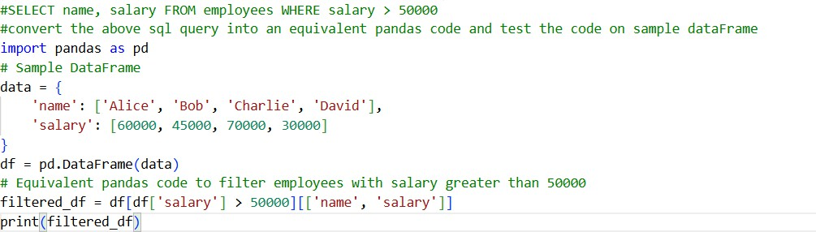

OUTPUT:
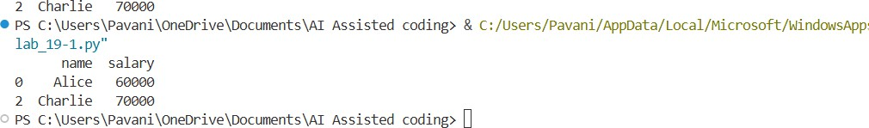

EXPLANATION:
- The SQL query is translated into Pandas by using boolean indexing to filter rows and selecting specific columns.
- A sample dataset is created using a dictionary and converted into a DataFrame for testing.
- The condition df['salary'] > 50000 filters employees with salaries greater than 50,000.
- The column selection ensures only name and salary are displayed, similar to the SQL query.

Task 4 – Real-Time Application: Multi-Language Snippet Converter PROMPT:
Choose a real-world use case and write code in one programming language. Then convert the same code into another programming language. Ensure both versions have the same functionality and output.Also include sample inputs, outputs

CODE:
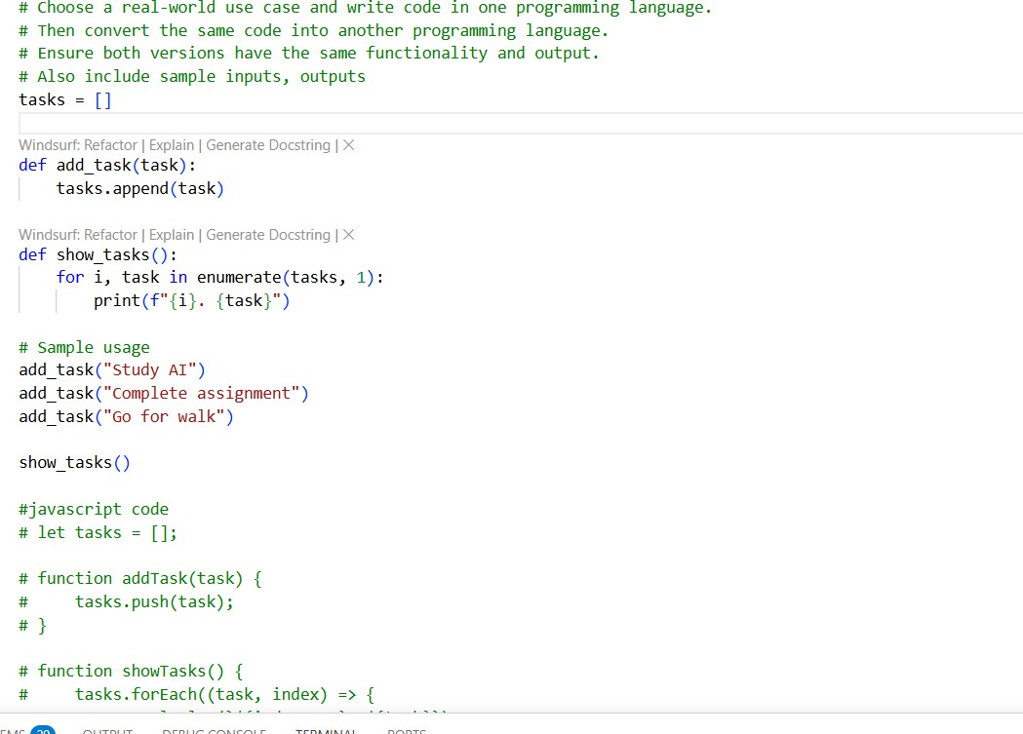

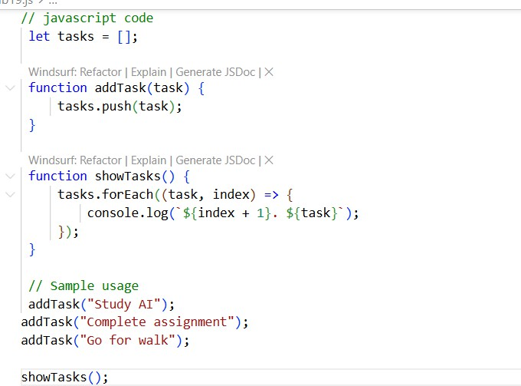

OUTPUT:
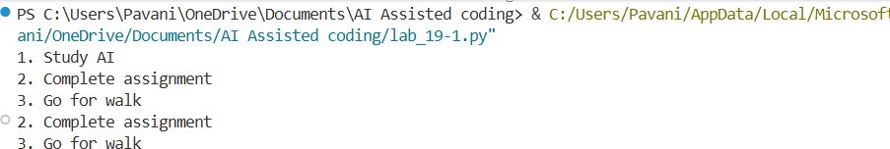

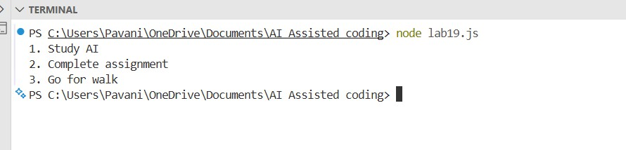
EXPLANATION:
- A real-world use case was selected where the same functionality was implemented in two different programming languages.
- AI was used to translate the code from one language to another while maintaining the same logic and output.
- Both implementations were executed and tested to ensure they produced identical results.
- During translation, challenges such as differences in syntax, libraries, and execution environments were identified and handled.

